|  |  |  |  |  |  |  |
| --- | --- | --- | --- | --- | --- | --- |
| **Practicum Final Exam – Odd Semester Year 2022/2023** | | | | | | |
| **Subject** | | | **COMP6799001 - Database Technology** | | |  |
| **Class** | **:** | **BA02 | BI01** | | **Start Date** | **: 4 January 2023** |
| **Lecturer** | **:** | **D2823 - Santy, S.Kom., M.Sc., PSM I**  **D6659 - Eko Setyo Purwanto, S.Pd., M.Kom.** | | **Start Time** | **: 17.20** |
| **End Date** | **: 4 January 2023** |
| **End Time** | **: 19.00** |

**PERATURAN UJIAN:**

*Exam Regulations:*

* Mahasiswa tidak diperbolehkan berdiskusi dan/atau bekerja sama dengan peserta ujian lainnya

*Student is not allowed to discuss and/or work together with other exam participants*

* Mahasiswa tidak diperbolehkan untuk membuka dan menyalin dari **BUKU** atau **CATATAN**, **VIDEO** dari pengajar (recording kelas, VBL, Youtube, dsb) dan **REFERENSI** lainnya

*Student isn't allowed to open and copy from any resources such as notes, videos (class recording, VBL, Youtube, etc) and other references*

* Mahasiswa tidak diperbolehkan membuka dan menyalin jawaban dari internet (google, stackoverflow, dsb)

*Student isn't allowed to open and copy answer from the internet (google, stackoverflow, etc)*

* Asisten **BERHAK** memberi nilai 0 **(NOL)** bagi peserta ujian yang melakukan segala bentuk kecurangan

*Assistant is able to give 0 (ZERO) score for exam participant who does any cheating actions*

* Kumpulkan jawaban tepat pada waktunya, apabila terlambat mengumpulkan maka jawaban tidak akan dikoreksi dan nilai mahasiswa adalah 0

*Submit the answer on time, if not, then the answer will not be checked, and the students will receive 0 (ZERO)*

* Bila Anda tidak membaca peraturan ini, maka aanda dianggap telah membaca dan menyetujuinya

*If you have missed to read these regulations, so you are considered to have read and agreed on it*

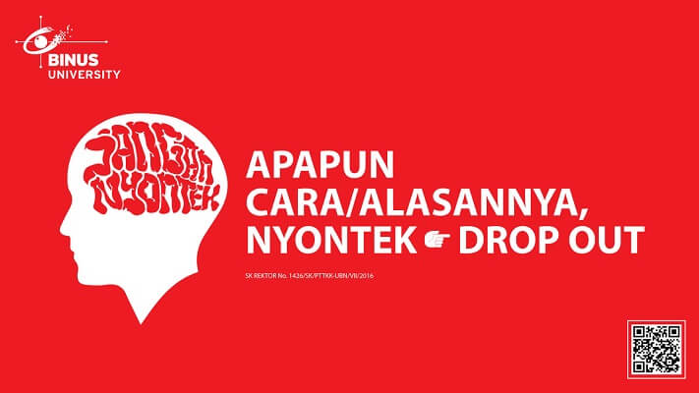

**SOFTWARE YANG DIGUNAKAN:**

*Software will be used:*

* XAMPP 8.0.7

**FILE YANG DIKUMPULKAN:**

*File must be collected:*

* SQL

**PERHATIAN!**

*Attention!*

* Bagi yang mengerjakan tidak sesuai dengan soal, maka akan diberikan nilai **NOL (0)**

*For those who do not work in accordance with the exam case will be marked as* ***ZERO (0)***

* Bagi yang mengerjakan tidak sesuai dengan software dan versi yang telah ditetapkan, maka akan tetap dikoreksi dengan software dan versi yang telah ditetapkan

*For those who do not work in accordance with the software and specific version will be corrected by the predefined software and version*

* Kompres semua jawaban yang akan diunggah. Pastikan format pengumpulan nama file dan ekstensi sesuai dengan format berikut: **[NIM]-[NAMA].zip**

*Compress all file that will be uploaded. Make sure the format for collecting file name and extension according to the following format:* ***[NIM]-[NAME].zip***

**Soal**

*Case*

**VA Stickers**

**VA Stickers** is a new platform for customer to buy stickers and for creators to sell stickers that they have created to be used on many messaging platform. The customer can buy more than one sticker in a single transaction.

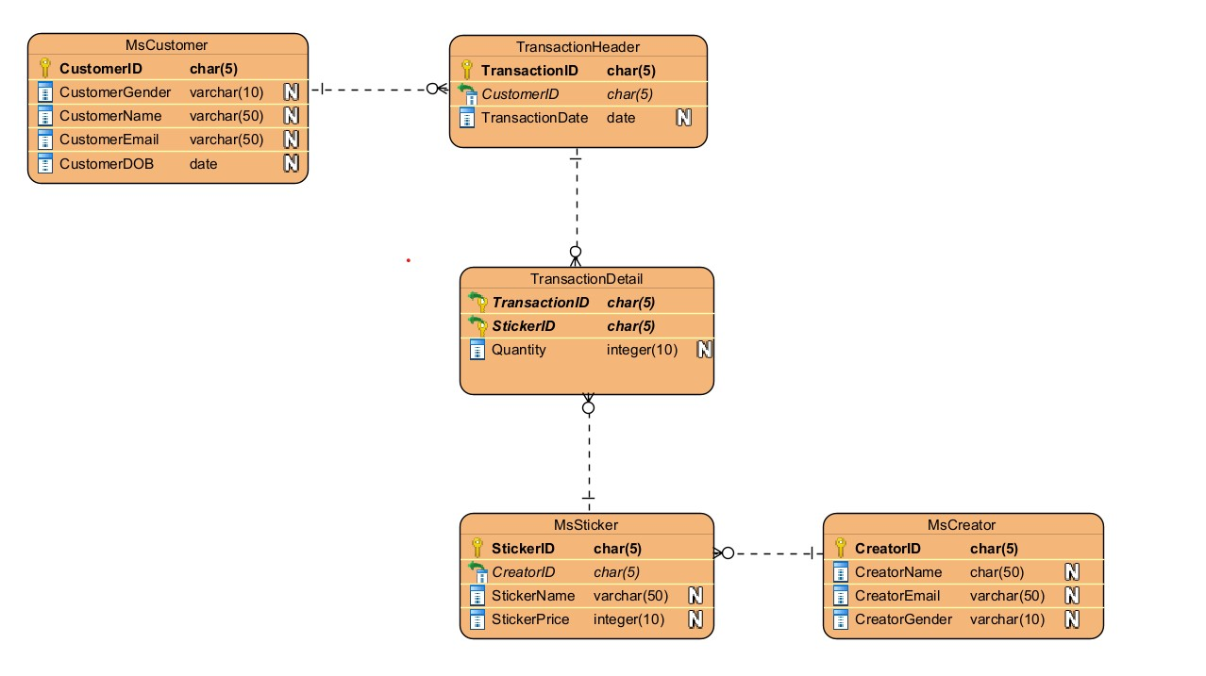

**Figure 1. ERD**

**Notes**

* Open **create+insert.sql** file (attached with the case), then **execute** the file on **MySQL.**
* Please **include the number of the question** in your answer SQL file.

1. **Import and use** the database **using SQL query**.
2. Display **TransactionID**, **CustomerName**, and **TransactionDate** for every customer that **has a transaction in 2022**.

**(YEAR)**

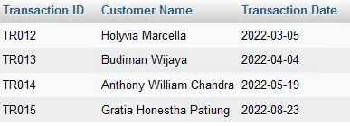

1. Display **CreatorName**, **StickerName**, **StickerPrice** (obtained by **adding ‘$ ’** in front of the **StickerPrice**) for every creator that **CreatorName begins** with **‘M’**. Then, combine it with **CreatorName**, **StickerName**, **StickerPrice** (obtained by **adding ‘$ ’** in front of the **StickerPrice**) for every **CreatorName begins** with **‘J’**.

**(CONCAT, UNION, LIKE)**

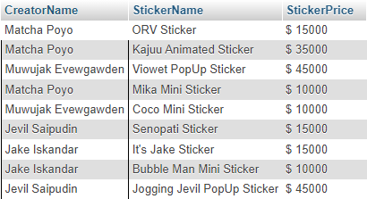

1. Display **TransactionID** (obtained by **replacing ‘TR’ with ‘Transaction-’**), **StickerName**, **CustomerName** (obtained from **CustomerName** in uppercase format) for every transaction which **StickerName** **contains** ‘**PopUp**’ and **CustomerName consists of at least 2 words**. Then, combine it with **TransactionID** (obtained by **replacing ‘TR’ with ‘Transaction-’**), **StickerName**, **CustomerName** (obtained from **CustomerName** in uppercase format) for every transaction which **StickerName** **contains** ‘**Mini**’ and **CustomerName consists of at least 2 words.**

**(REPLACE, LOCATE, LIKE, UNION, UPPER)**

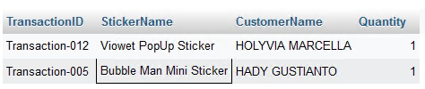

1. Add **StickerCategory** as new column on **MsSticker** table with **char(10) data type** and add a **constraint** on **MsSticker** table to validate **StickerCategory must be either ‘Fanmade’** **or ‘Official’**.

**(ALTER TABLE, ADD COLUMN, IN)**

**Before**

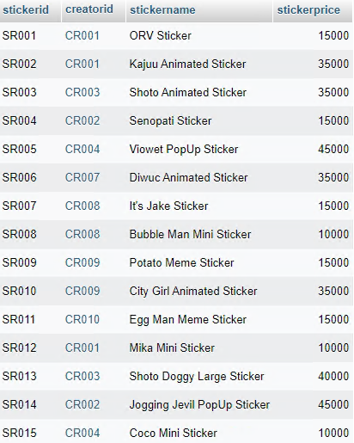

**After**

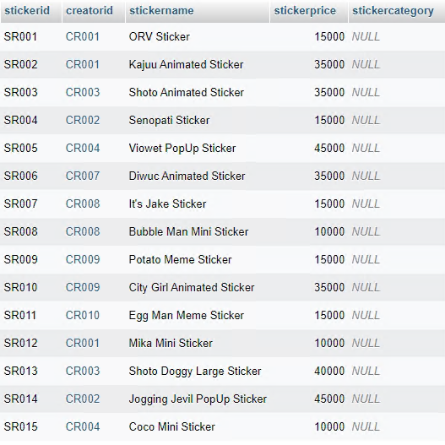

1. Delete data from **MsCustomer table** for every customer that **has a transaction in 2022** and their **name starts with ‘H’**.

**(DELETE, YEAR, LIKE)**

**Before**

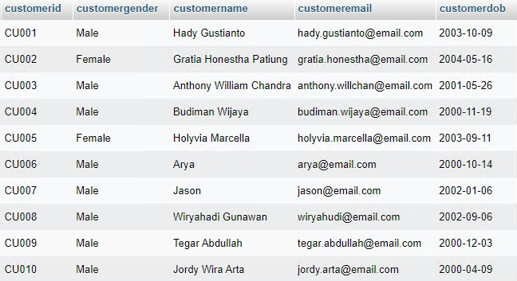

**After**

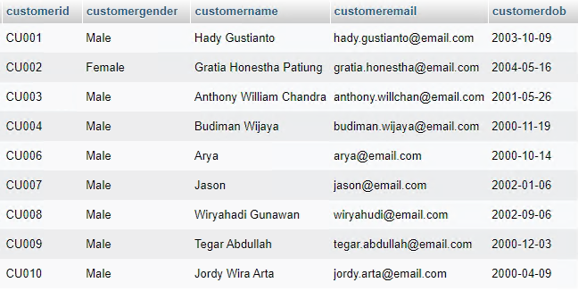

1. Display **Transaction Date** (obtained from **TransactionDate** in ‘**Day, dd Month yyyy**’ format), **CreatorName**, **StickerName**, **QuantityBought** (obtained from **Quantity**), **StickerPrice** ,and **TotalPrice** (obtained from **Quantity multiplied by StickerPrice**) for every creator whose id is **‘CR003’** or **‘CR004’** and **TotalPrice** is **more than 35000**.

**(DATE_FORMAT, IN)**

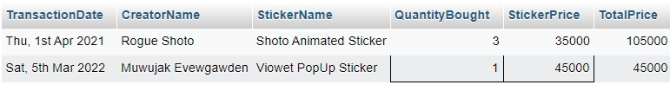

1. Display **TransactionNumber** (obtained from **the last 3 letters of TransactionID**), **StickerID**, **StickerName**, and **QuantityBought** (obtained from **Quantity**). After that, **sort** the result by **TransactionNumber** in **descending** format.

**(RIGHT, ORDER BY)**

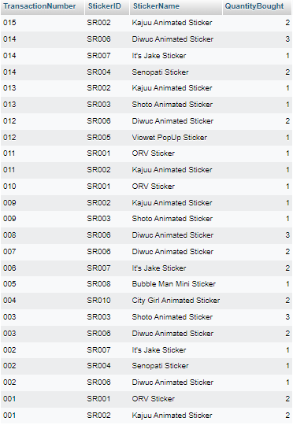

1. Create a **view** named ‘**viewFirstWordFromStickerName**’ to display **StickerID**, **CreatorName**, and **StickerName** (obtained from **taking the first word** of the **StickerName**)**.**

**(CREATE VIEW, SUBSTRING, LOCATE)**

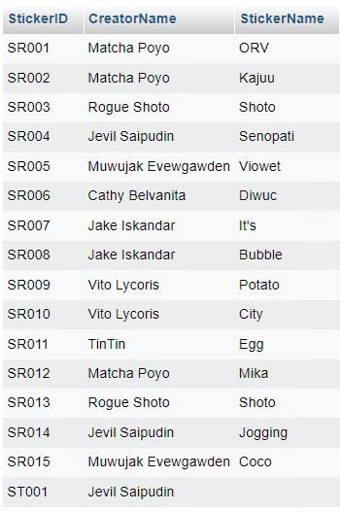

1. Create a **view** named ‘**viewStickerDescriptionPerTransaction**’ to display **TransactionID** (obtained by **replacing ‘TR’ with ‘Transaction-’**), **StickerDescription** (obtained by **combining CreatorName** and **StickerName** in **uppercase** formatwith combination format **‘[CreatorName]-[StickerName]’**), and **QuantityBought** (obtained from **Quantity**)**.**

**(CREATE VIEW, REPLACE, CONCAT_WS)**

